**Training Announcement**

**Wisconsin**

**2nd Annual Prescribed Fire Training Exchange**

**(WI-TREX) Wisconsin**

**April 9th – April 25th, 2018**

**Objectives:** Assemble a diverse group of fire practitioners working together to share and build their experience in prescribed fire practices, fire effects, and other conservation efforts affecting forests and grasslands throughout Wisconsin. Expose students to a variety of agency burn concepts and fuel models administered by the US Fish and Wildlife Service, Wisconsin Department of Natural Resources, Aldo Leopold Foundation and The Nature Conservancy.

**Target Group:** Prescribed fire and wildfire personnel involved in fire and ecosystem management, including federal, state, tribal, non-governmental, and private practitioners. Preference will be given to Burn Bosses, Firing Boss and Fire Fighter 1 trainees but all positions or experience level are welcome to apply to fill out modules.

**Tuition:** $300 ; tuition is due upon acceptance to the training and non-refundable

**Description:** Participants will engage in a unique program which maximizes field prescribed burning experience blended with a flexible curriculum of classroom instruction on foundational topics. Participants will have the opportunity to complete portions of their National Wildfire Coordinating Group (NWCG) approved task books. The burning will take place across the state of Wisconsin working with local partners encompassing a variety of fuel models; US Fish and Wildlife Service, Wisconsin Department of Natural Resources, The Nature Conservancy. Each participant will also prepare and present a briefing focused on the fire regimes, management challenges, and opportunities within their home region. In addition, participants will practice preparing for media interviews. During non-burn days additional training may be offered such as All Terrain Vehicle Operations (ATVO) course, Specialty Tracked Operations (STOP) course, and Chainsaw Recertification for level 2 and 3.

**Requirements:**

• Current RED CARD

UTVO Qualified; All partners in Wisconsin use Utility Terrain Vehicles extensively in prescribed

burning. Preference will be given to those who possess this qualification.

• All participants must complete basic US federal firefighter safety courses IS100, S130, S190, L-180 and NIMS IS700;

• Participants must complete an arduous pack test before participating in the training, confirming the ability to walk 3 miles with 45 pounds in 45 minutes.

• Participants must bring fireline PPE; Nomex shirt and pants, fire shelter, helmet, fireline-approved boots (all-leather workboots, 8 inches tall, with non-slip soles and no steel toe), gloves, eye protection, hearing protection, headlamps, and anything you like to have on the fireline.

**Meals:** Students will be on their own for meals during their training.

**Lodging**: Lodging will be provided during this detail (houses, cabins, hotels). Please bring a sleeping bag and towel.

**Travel:** Your home unit will be responsible for your travel to and from the training. Once in Wisconsin, the training will provide lodging and transportation during operations. More information will be sent out to successful applicants with travel logistics.

**Time**: Your home unit will be responsible for covering your time, and any overtime incurred during the training and per diem during travel status to and from the Training.

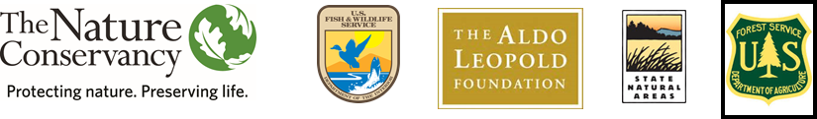 **Registration:** To apply for this training, complete the registration form and submit to Eric Mark, [emark@tnc.org](mailto:emark@tnc.org) by **February 15th, 2018**. Space is limited; selection will be made to ensure an agency diverse group. Those selected will receive an acceptance letter and invitation from The Nature Conservancy to use for travel planning.